
Touchstones Project
Netcards

Transformation Netcards with Text

Actress HRJ
Advocacy HRJ
Awakening HRJ
Bird HRJ

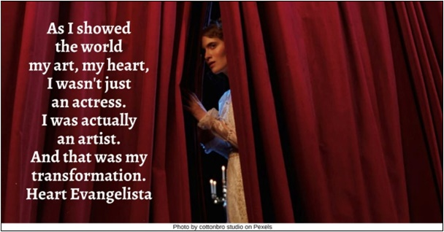

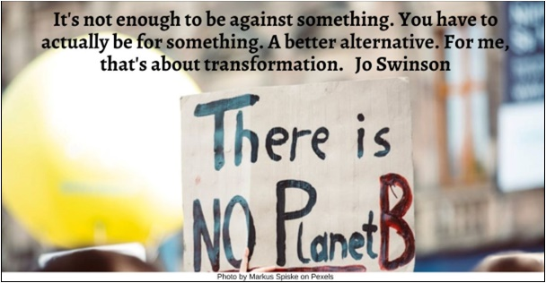



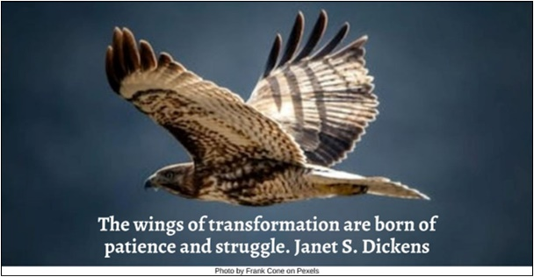

Calendar HRJ
Challenge HRJ
Child Playing HRJ
Choose HRJ

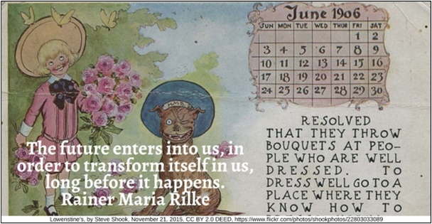



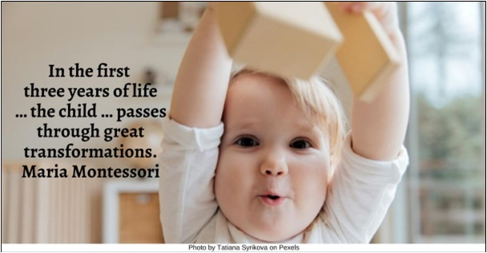

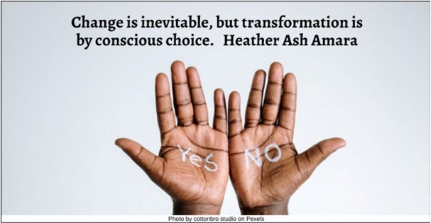

Church HRJ
Cocoon HRJ
Confusion HRJ
Fairy Tale HRJ



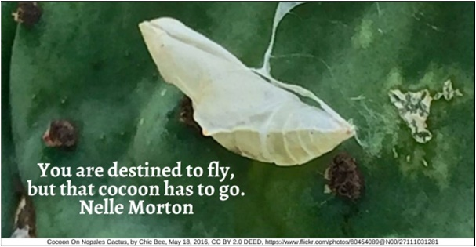

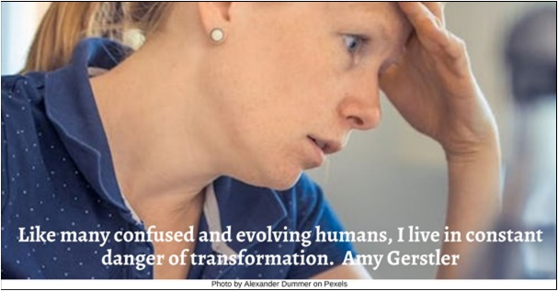



Fall HRJ
Healing HRJ
Kindness HRJ
Mandela HRJ

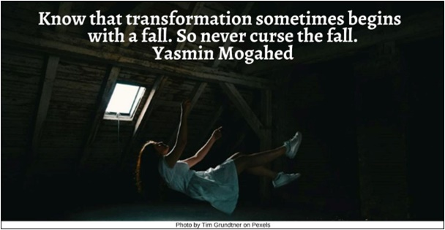

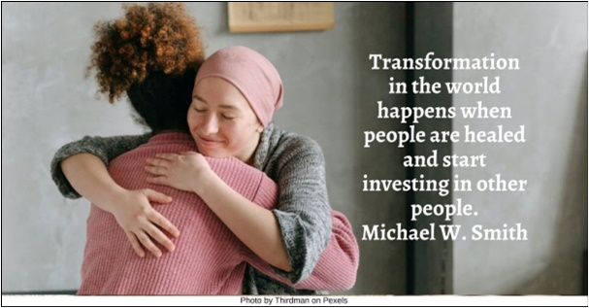

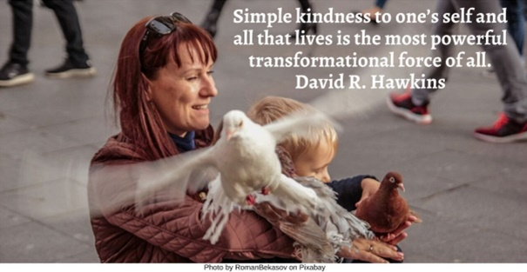

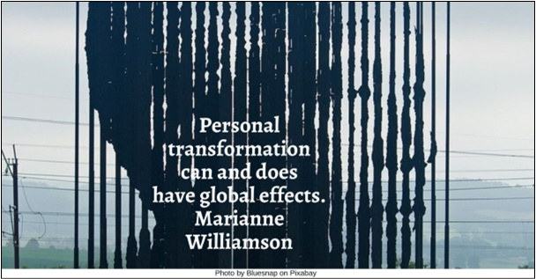

Meditation HRJ
Memory HRJ
Mistakes HRJ
Monk HRJ





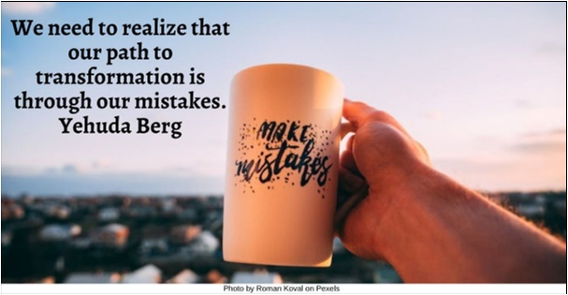

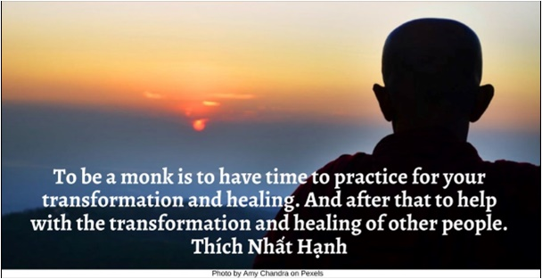

Peace HRJ
Questions HRJ
Rituals HRJ
Recognize HRJ

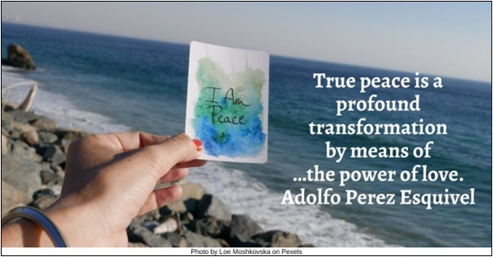

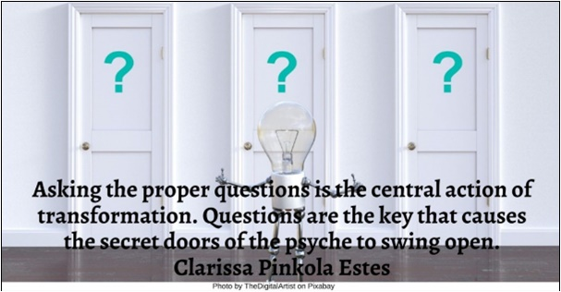





Ruler HRJ
Severe Illness HRJ
Today HRJ
Travel HRJ





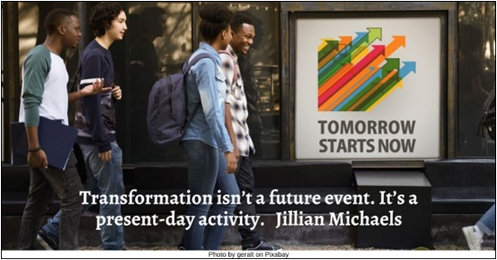



Turtle HRJ
Waves HRJ
Yoga HRJ

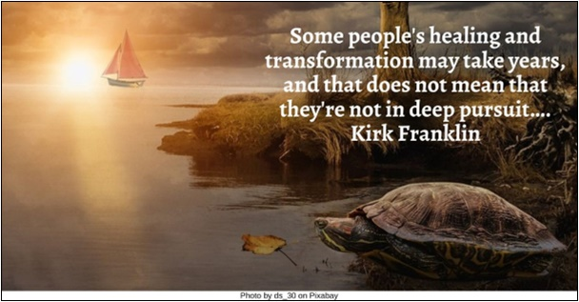

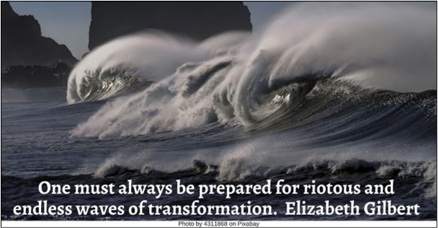



Text of Quotes
Actress HRJ
As I showed the world my art, my heart, I wasn't just an actress. I was actually an artist. And that was my transformation. Heart Evangelista

Advocacy HRJ
It's not enough to be against something. You have to actually be for something. A better alternative. For me, that's about transformation. Jo Swinson

Awakening HRJ
Awakening is not a thing. It is not a goal, not a concept. It is not something to be attained. It is a metamorphosis. Alejandro Jodorowsky

Bird HRJ
The wings of transformation are born of patience and struggle. Janet S. Dickens

Calendar HRJ
The future enters into us, in order to transform itself in us, long before it happens. Rainer Maria Rilke

Challenge HRJ
Embrace each challenge in your life as an opportunity for self-transformation. Bernie Siegel

Child Playing HRJ
In the first three years of life … the child … passes through great transformations. Maria Montessori

Choose HRJ
Change is inevitable, but transformation is by conscious choice. Heather Ash Amara

Church HRJ
I hate thinking about how many people have gone to church for decades and remain joyless or judgmental or bitter or superior. John Ortberg

Cocoon HRJ
You are destined to fly, but that cocoon has to go. Nelle Morton

Confusion HRJ
Like many confused and evolving humans, I live in constant danger of transformation. Amy Gerstler

Fairy Tale HRJ
Fairy tales are stories of triumph and transformation and true love, all things I fervently believe in. Kate Forsyth

Fall HRJ
Know that transformation sometimes begins with a fall. So never curse the fall. Yasmin Mogahed

Healing HRJ
Transformation in the world happens when people are healed and start investing in other people.
Michael W. Smith

Kindness HRJ
Simple kindness to one’s self and all that lives is the most powerful transformational force of all. David R. Hawkins

Mandela HRJ
Personal transformation can and does have global effects. Marianne Williamson

Meditation HRJ
The purpose of meditation is personal transformation. Henepola Gunaratana

Memory HRJ
Memory is a code to who we are, a collection of not just dates and facts but also of epic emotional struggles, epiphanies, transformations. David Grann

Mistakes HRJ
We need to realize that our path to transformation is through our mistakes. Yehuda Berg

Monk HRJ
To be a monk is to have time to practice for your transformation and healing. And after that to help with the transformation and healing of other people. Thích Nhất Hạnh

Peace HRJ
True peace is a profound transformation by means of …the power of love. Adolfo Perez Esquivel

Questions HRJ
Asking the proper questions is the central action of transformation. Questions are the key that causes the secret doors of the psyche to swing open. Clarissa Pinkola Estes

Rituals HRJ
Rituals, anthropologists will tell us, are about transformation. Abraham Verghese
Photo by yogendras31 on Pixabay

Recognize HRJ
I beg your pardon. I didn’t recognize you. I’ve changed a lot. Oscar Wilde

Ruler HRJ
Transformation in real life is extraordinarily incremental, and that's all I'm going to say. Jillian Michaels

Severe Illness HRJ
When people are facing a severe illness or a major surgery, that may be one of the most significant opportunities for spiritual transformation that they will encounter. Allan Hamilton

Today HRJ
Transformation isn’t a future event. It’s a present-day activity. Jillian Michaels

Travel HRJ
Travel for me is all about transformation…. Pico Iyer

Turtle HRJ
Some people's healing and transformation may take years, and that does not mean that they're not in deep pursuit…. Kirk Franklin

Waves HRJ
One must always be prepared for riotous and endless waves of transformation. Elizabeth Gilbert

Yoga HRJ
The great solution to all human problems is individual inner transformation. Vernon Howard

